

SOUTHBANK PARTNERS NEWSLETTER – SEPTEMBER, 2013

**SOUTHBANK CITIES RECEIVE $481,600 IN OKI GRANTS**

The Ohio-Kentucky-Indiana Regional Council of Governments (OKI) has awarded four Southbank Partners cities – Bellevue, Covington, Ludlow and Newport – grants totaling $481,600 for projects that are components of the Riverfront Commons walking path.

“We still have a long way to go, but this is a major step toward making Riverfront Commons a reality,” said Southbank Partners President Jack Moreland. “This is big news for Southbank and its big news for our cities.”

Riverfront Commons is a planned to be an integrated, continuous public riverfront pathway of multi-use trails, plazas, overlooks, parks and event places that link the Southbank communities.

In addition to the OKI funding, the projects also include $120,000 in matching funds.

Southbank cities receiving grants for portion of the Riverfront Commons walkway are:

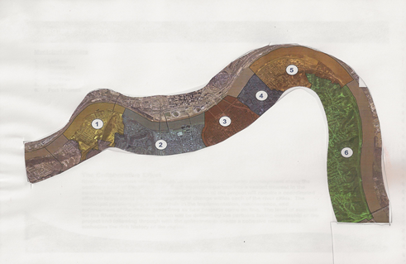

* Ludlow, $230,406.
* Covington, $227,868.
* Newport, $129,631.
* Bellevue, $17,483.

The longest piece of the projects covers more than 3,800 feet from the former Covington Landing site at the foot of Madison Avenue west to near the Ludlow city line.

The portion of the project will make it easier for guests at Covington hotels to walk east to the Northern Kentucky Convention Center.

**DUKE ENERGY AWARDS SOUTHBANK $10,000 PARK GRANT**

Duke Energy has awarded a $10,000 grant to Southbank Partners that will support development of The Taylor Creek Overlook, a new riverfront park planned in Northern Kentucky.

Taylor Creek Overlook is being developed on land between Riverboat Row and KY Route 8 on the Newport/Bellevue line. The park will feature an overlook plaza with sculptures, benches and telescopes along with trees and underbrush. Taylor Creek Overlook will ultimately become part of the Riverfront Commons river trail that is being planned along the Northern Kentucky riverfront.

“Duke Energy is pleased to provide this environmental grant that will benefit our customers in Bellevue and Newport,” said Rhonda Whitaker, director, government and community relations, Duke Energy Kentucky. “We applaud Southbank Partner’s efforts to work with these communities on a project that will enhance the riverbank area between these cities and provide a new green space venue in Northern Kentucky.”

State Rep. Dennis Keene, D-Wilder, who represents the Southbank cities of Newport, Bellevue and Dayton, helped secure state funding for the $1.8 million park. Taylor Creek Overlook is still in the design phase. Construction is expected to be completed by late spring or early summer of 2014.

Southbank Partners President Jack Moreland said the project will also improve a large culvert where Taylor Creek in Campbell County flows into the Ohio River on the Newport/Bellevue line.

“Southbank Partners is very grateful for Duke Energy’s continued support of Northern Kentucky’s urban core,” Moreland said. “Development of the Taylor Creek Overlook is another opportunity to complete a portion of Riverfront Commons.”

**SOUTHBANK HOSTING BUSINESS DEVELOPMENT SERIES**

Southbank Partners and the Northern Kentucky University Small Business Development Center are partnering to offer a seven-week program on starting a business in the Southbank Partner cities.

The series begins Oct. 2 and spans seven weeks with classes held each Wednesday night from 6:30 p.m. to 8:30 p.m. on the second floor of the Southbank office at 425 York St. in Newport.

“The program will be an innovative mix of core business development and management principles with a tailored presentation of the urban core market that showcases commercial vacancies and particular districts as opportunities, existing and proposed specialty business clusters in each community, available incentives and urban market demographics,” said Southbank Partners President Jack Moreland.

The series will be facilitated and taught by Rebecca Volpe, director of NKU’s Small Business Development Center, and augmented by speakers with expertise on each week’s lesson. Prior to joining the center, Volpe worked as a business recruitment and retention specialist for the City of Covington.

Following is the proposed agenda:

* Week 1: **Are You Ready to be an Entrepreneur.** What it takes to be a business owner; can you raise the capital you need; industry specifics and fundamental startup concepts introduced.
* Week 2: **Southbank Cities Panel.** Panel presentation featuring members of each Southbank city presenting information relative to economic development efforts with a focus on incentives, cost of doing business, zoning and areas of opportunities.
* Week 3: **Evaluating the Market**. Presentation of unique opportunities in the urban core river cities, urban core demographics, defining a trade area, market analysis and opportunity, competitive intelligence and value proposition.
* Week 4: **Can You Make $$$: Creating a Revenue Model and Business Plan**. Projecting startup and fixed costs and income; beginning the business plan.
* Week 5: **Legal Foundation and Accounting Essentials.** Understanding the necessary legal foundation to have in place for your enterprise; understanding basic accounting principles such as reading a profit/loss statement and a balance sheet and understanding cash flow.
* Week 6: **Good Business Management/Access to and Sources of Business Capital**. “Must have” management principles and resources for capital.
* Week 7: **Finishing the Business Plan and the Marketing Plan**. Review of essential elements; creation of a sustainable and realistic business plan; creating a “must have” marketing plan; marketing strategies; digital/social and earned media strategies.

Registrations are open until Sept. 27 and can be made by contacting:

Joyce McMullin

Southbank Partners

859-655-7700

[jmcmullin@southbankpartners.com](mailto:jmcmullin@southbankpartners.com)

**SOUTHBANK PARTNERS CITIES NEWS**

BELLEVUE

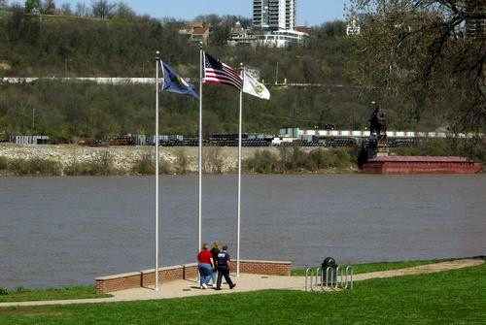

Bellevue will hold its annual Art in the Park event Saturday, Sept. 14, at the Bellevue Beach Park at the foot of Ward Avenue along the Ohio River. Sponsored by WNKU, Art in the Park is a community festival featuring more than 90 local artists, musicians and food in a charming urban green space. (Shop Bellevue!)

During the event, the city will present the Second Saturday Concert with music by Scott Sprague and Fiends – The Reunion Concert. Sprague, a Bellevue native and resident, is on of Northern Kentucky’s most accomplished and talented guitar players. The concert begins at 7 p.m. at the Bellevue Beach Park. (Shop Bellevue!)

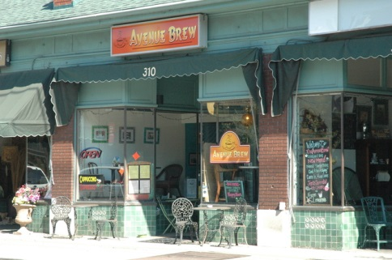

For more information on these and other events, log on to [www.shopbellevue.com](http://www.shopbellevue.com).

COVINGTON



UpTech has new headquarters in Covington, a new fund manager and new investors in its vision to build a cluster of technology companies in Northern Kentucky. On Sept. 9, it also will launch eight new companies on a six-month program that includes up to $50,000 of equity investment, office space and access to resources. (Kentucky Enquirer)

<http://news.cincinnati.com/article/20130825/BIZ/308210126/Uptech-s-second-class-startups-works>

A new tenant in Covington's RiverCenter towers will occupy 22,200 square feet and add 180 jobs to the local economy by 2016, it was announced Tuesday night at the Covington City Commission meeting. (River City News)

<http://rcnky.com/articles/2013/08/20/company-locate-covingtons-rivercenter-towers-will-add-180-jobs-2016>

The City of Covington will have a new brand identity by the end of 2013 and the company behind the effort has extensive history in working with world-class products, cities, and destinations. Landor Associates, a Cincinnati-based marketing giant with offices across the globe, has worked with cities like Baltimore and Roanoke and helped lay out an identity for the 9/11 Museum. (River City News)

<http://rcnky.com/articles/2013/08/08/company-brand-covington-worked-baltimore-911-museum-projects>

DAYTON

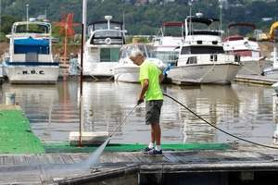

A waterfront development boasting luxury living is gaining steam as the city of Dayton enters into a new lease for Manhattan Harbour marina. East End-based developer DCI Properties has been moving and filling ground to make way for the long-awaited Manhattan Harbour development, a 73-acre multi-use complex on Dayton’s waterfront. Now, WDG, Waterfront Development Group, also of Cincinnati, has agreed to enhance the city-owned marina just east of the project to create a top-scale destination for residents and visitors. (Kentucky Enquirer)

<http://nky.cincinnati.com/article/AB/20130822/NEWS0103/308220029/Dayton-Ky-dreaming-big-about-Manhattan-Harbour?odyssey=mod%7Cnewswell%7Cimg%7CFRONTPAGE%7Cp>

The city of Dayton is holding a Stick Horse competition “to help beautify our storefronts and city,” according to a notice on the city’s website. “This is a fun event that we encourage everyone, however talented, to participate in. Stick Horses will be on display to the public for the remainder of the year.” Completed Stick Horses are due Monday, Sept. 23, by 5 p.m. For an application and for more information, visit [www.daytonky.com](http://www.daytonky.com).

FORT THOMAS

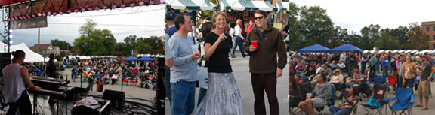

Two major country music acts – John Michael Montgomery and The Kentucky Headhunters – headline Fort Thomas’ 10th Annual Merchants & Music Festival. The day-long Sept. 28 event runs from 2 p.m. to 11:30 p.m. at Tower Park and is free and open to the public. Also scheduled to perform are Chris Janson, Lyndsey Highlander, HHS Sinfonia, Aly’ An, The Sleepin’ Dogs and The Carter New Band. Food and drinks will be available. For more information visit [www.merchantsandmusic.com](http://www.merchantsandmusic.com).

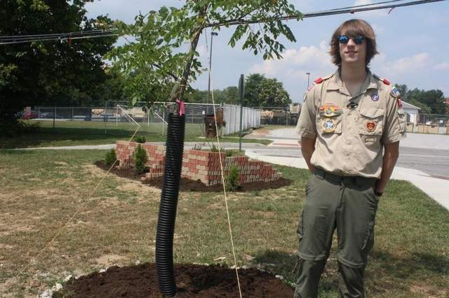

Evan Zuelke always got a kick out of playing soccer, so for his Eagle Scout project he left the practice field area in Tower Park where he played better than he found it. Zuelke, of Fort Thomas, has completed a raised brick-edged flower bed suitable for a sign for the Army Reserve Practice Fields at Army Reserve Road and Sergeant Avenue. He also planted two trees and built four steps into a hillside to the fields. (Kentucky Enquirer)

<http://nky.cincinnati.com/apps/pbcs.dll/article?AID=/AB/20130823/NEWS0103/308230108/>

LUDLOW

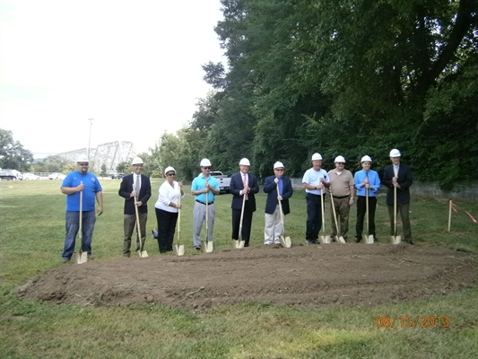

After years of keeping city equipment housed in ‘temporary’ quarters that are too small, the city of Ludlow is constructing a new public works building that pays tribute to the Ohio River city’s railroad past. (Kentucky Enquirer)

<http://news.cincinnati.com/article/20130814/NEWS0103/308140114/New-building-pay-tribute-Ludlow-s-past?nclick_check=1>

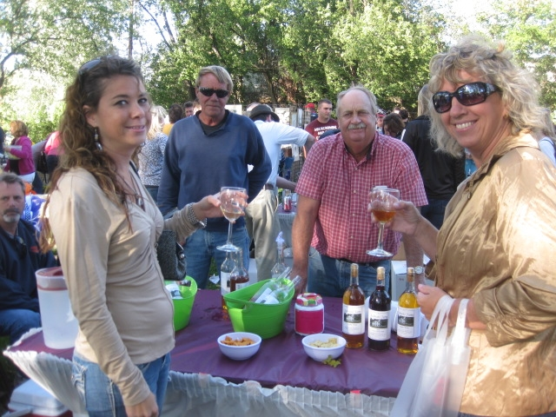

On Sept. 21, the Ludlow Civic Club will host its fourth annual wine tasting on the grounds behind the VFW Hall at 830 Elm Street from 3 pm to 7pm. Six Northern Kentucky Wineries participating: Stonebrook Vineyards, Seven Wells Vineyard & Winery, Rose Hill Farm Winery, Redman's Farm Winery, Baker Bird Winery and Generation Hill Winery. For more information visit [www.ludlow.org](http://www.ludlow.org).

NEWPORT



Burgeoning development is going to require this 1.5-square-mile river city to make way for more parking, and maybe more development. Newport City Manager Tom Fromme said during his recent State of the City Address that the city will consider a $5 million to $6 million bond issue this fiscal year so that Newport is poised for growth. <http://news.cincinnati.com/article/20130828/NEWS0103/308280105/Parking-top-list-Newport-s-future>

Newport Pavilion promised a clothing store and now it’s scored one.

T.J. Maxx will lease 23,250 square feet at a location next to Dick’s Sporting Goods, opposite the main drag of Newport Pavilion. (Kentucky Enquirer)

<http://nky.cincinnati.com/apps/pbcs.dll/article?AID=2013308270066&site=AB>



As a luxury apartment complex on Newport’s riverfront nears completion, it not only is attracting tenants but providing a more alluring landscape for developers who turn an eye toward Northern Kentucky. Vue180 recently held a sneak peek for local officials, prospective tenants and the public. (Kentucky Enquirer)

<http://news.cincinnati.com/article/20130802/NEWS0103/308020130/Sneak-peek-Newport-s-new-luxury-apartments>